

**Appendix '1'**

Contents

**Page number**

Introduction 3

Purpose of 2016-19 Business and Delivery Plan 4

A Review of 2015-16 5

Governance and Implementation 6

* Infrastructure Delivery
* Planning and Delivery
* Community Infrastructure
* Employment and Skills
* Monitoring
* Communications and Marketing

Finance 9

Housing Sites 16

Infrastructure Delivery 2016-19 23

Zone 1 – North West Preston 25

Zone 2 – North East Preston 40 Zone 3 – Preston City Centre 40

Zone 4 – Penwortham and Lostock Hall 51

Zone 5 – Leyland and Cuerden 60

Zone 6 – Bamber Bridge 64

Risk 69

Index of infrastructure schemes and development sites 74

1. **INTRODUCTION**

The Preston, South Ribble and Lancashire City Deal was agreed with Government in 2013 and has been designed to drive forward local growth by empowering the City Deal to make the most of its economic assets and opportunities. The City Deal is an ambitious programme of work that builds on the strong economic performance of the area over the last ten years and will help ensure the City Deal area continues to grow by addressing strategic transport infrastructure challenges to enable the delivery of new jobs and housing.

The City Deal partners are the Lancashire Enterprise Partnership (LEP), Central Government, Lancashire County Council (LCC), Preston City Council (PCC), South Ribble Borough Council (SRBC) and the Homes and Communities Agency (HCA).

The City Deal is a ten year infrastructure delivery programme. It is funded through pooled local and national private and public sector resources. The private sector are contributing through Community Infrastructure Levy (CIL) and other developer contributions. The Department for Transport (DfT) is investing through Local Major funding, the LEP through the Growth Deal, the HCA through the local retention of value uplift from land sales and the councils via New Homes Bonus (NHB), Business Rates (NNDR), capital programme resources and land.

The City Deal will generate:

* More than 20,000 net new private sector jobs, including 5,000 in the Lancashire Enterprise Zone;
* Nearly £1 billion growth in Gross Value Added (GVA);
* 17,420 new homes; and
* £2.3 billion in leveraged commercial investment.

The City Deal partners have established a City Deal Infrastructure Delivery Programme and City Deal Investment Fund, which together are worth £450m over the lifetime of the Deal.

The City Deal Infrastructure Delivery Programme will enable delivery of critical highway infrastructure and allow the full development of significant commercial development and housing schemes. This includes four highway schemes and local community infrastructure, such as schools and health facilities, required to support the scale of such ambitious development.

1. **PURPOSE OF THE 2016/19 BUSINESS AND DELIVERY PLAN**

The delivery of a successful City Deal is dependent upon robust programme and project management principles that align the delivery of strategic highway and community infrastructure with the development of the housing and employment sites identified in the City Deal area.

The City Deal partners have agreed that two plans, a Business and Delivery Plan and a HCA Business and Disposal Plan (BDP) be presented annually to the City Deal Executive and Stewardship Board.

The purpose of this Plan is to set out the delivery programme for the strategic highway infrastructure and community infrastructure over the period 2016 - 2019. Milestones for the delivery of the Housing and Commercial Sites are currently being reviewed and will be detailed in the refreshed version of this Plan in Spring 2017. The purpose of the BDP is to set out the HCA's annual disposal plan for HCA assets contained in the City Deal.

The proposals set out in this Plan demonstrate the commitment between Central Government, the LEP, the HCA, Lancashire County Council, Preston City Council, South Ribble Borough Council, skills and employment providers and the private sector to work together to deliver the City Deal.  This ongoing commitment will be communicated each year, by providing an updated version of this Plan.

1. **A REVIEW OF YEAR TWO**

A detailed annual review of performance was presented to the City Deal Executive and Stewardship Board in June 2016. In Year two expenditure from the City Deal Infrastructure Delivery Fund in 15/16 was £14.66m against income received of £27.884m. A number of significant milestones were achieved in 15/16 which have established a strong position to build on in Year 3 of the Programme. Notable milestones include:

**Highway Infrastructure:-**

* Broughton Bypass – all funding approvals in place, contractor appointed and construction underway.
* Preston Western Distributor – Early contractor involvement secured, public consultation completed and planning application prepared and being validated ready for submission early 2016/17.
* A582 – Dualling work – Golden Way North section completed. Golden Way South - concept design approved and route adopted. Stanifield roundabout complete and tank roundabout works underway.

**Transport Corridors**

* Fishergate Central Gateway – Phase 2a complete
* Bamber Bridge – Concept design approved

**Housing Sites**

* 6 monthly target for housing completions achieved and 2015/16 target of 800 on course to be met
* Since the start of the City Deal 16,000 new homes have been completed ahead of a forecast of 1200

**Employment Sites**

* Masterplan approved for Cuerden, the largest employment site in the City Deal
* Completions and lettings of new speculative light industrial units in Preston and South Ribble

**Local Partner Assets**

* Implementation of a co-ordinated development plan for City Centre North, Preston.
* Letting of new logistics units at Lancashire Business Park, South Ribble.

**Community Infrastructure**

* Worden Park Improvements – External access improvements, extension of exiting car park and road/footpath improvements completed

**Employment and Skills**

* Study commissioned and report produced identifying the skills and employment implications of the City Deal programme.
* City Deal Skills and Employment Group established to develop an action plan and oversee its implementation.
* Careers Education, Information, Advice and Guidance Taskforce launched.

Governance and Implementation

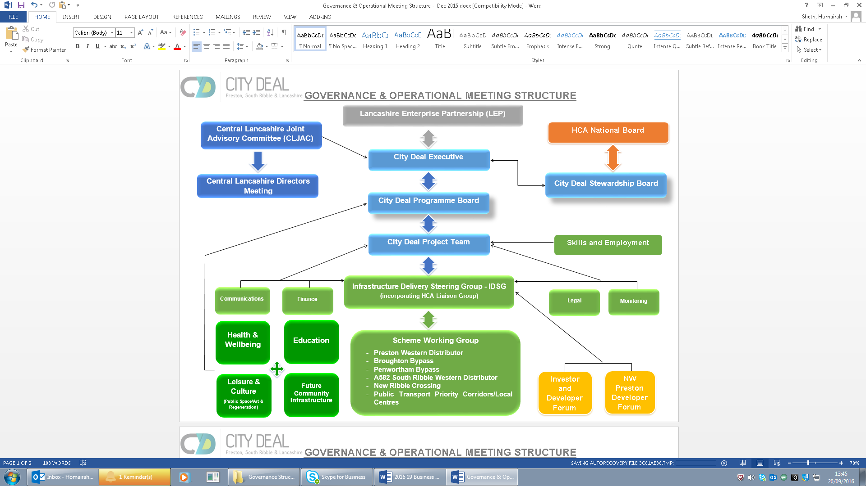There is a robust governance structure for the City Deal which directs and oversees the implementation and performance of the programme. The Governance arrangements, supported by a number of operational delivery groups, are shown below.

**Infrastructure Delivery**

The Infrastructure Delivery Steering Group (IDSG) is responsible for developing the infrastructure elements of this Plan on an annual basis, and once approved by the Executive and Stewardship Board, the IDSG oversees infrastructure implementation. It has recently taken on the responsibilities of the former HCA Liaison Group in relation to site disposals, and acts as a catalyst for addressing any blockages that might delay progress. The IDSG will also oversee the delivery of the Community Infrastructure Plan, once it has been developed and approved.

**Planning and Delivery**

The Central Lancashire Planning Directors' Group helps ensure that a strong development management approach is in place to support the delivery of the City Deal Housing and Employment sites. A priority in 2016/17 for the City Deal Executive and Stewardship Board, is to develop a better coordinated and focussed approach to the delivery of those sites going forward. The timely delivery of the development sites is critical to the achievement of the aims of the City Deal, and underpins the City Deal finance model. Whilst the site delivery is predominantly private sector led, there is a lot that the Partners can do to facilitate the accelerated delivery of sites, at key stages of the pre planning and planning process. The City Deal Executive and Stewardship is committed to ensuring that the planning process in the City Deal area provides the necessary 'enabling' support to applicants as part of a strong investment proposition for developers. This development management approach will include:-

* Site by site analysis, identifying any risks to development and proposing mitigating measures.
* Identify and remove/monitor blockages in the system that are holding up development.
* Streamline planning processes to ensure that City Deal sites/schemes are dealt with swiftly.
* Identify a single contact point for each development site to maintain the momentum set out in the overall programme
* Ensure a shared understanding across the planning authorities of the importance of the sites to the City Deal.
* Strengthen the role of the Central Lancashire Joint Advisory Committee in achieving sustainable development on City Deal sites.

**Community Infrastructure**

A City Deal Community Infrastructure Plan (CIP) is being developed and will be presented to the City Deal Executive and Stewardship Board in 2017 for approval. The Demographic modelling exercise currently underway will be used to inform the content of the CIP which will set out funding proposals for schemes falling into one of the agreed four categories; Health and Wellbeing, Education, Leisure and Culture and Future CI Improvements. The schemes will be approved by the Executive and Stewardship Board when income is secured and has been paid into the Fund. In advance of that, the list of smaller scale CI projects already approved has been brought forward and included in the Infrastructure Delivery section of this Plan.

**Employment and Skills**

The City Deal Executive and Stewardship Board approved a Skills and Employment Strategy and Action Plan in 2015- <http://www.lancashirelep.co.uk/lep-priorities/skills-employment/evidence-base.aspx>). Key activity for 2016-2019 is set out in the Action Plan, which focusses on measures to: ensure there are sufficiently skilled workforces to support both the construction industry and the growth sectors in the local economy; maximise the social value and training and employment opportunities from construction sector activity; and provide training and skills to secure inward investment and company expansion in the City Deal area.

**Monitoring**

Monitoring is undertaken on both implementation and impact of the City Deal programme. Six monthly monitoring reports on core and supporting metrics are provided to Government and the City Deal Executive and Stewardship Board receive quarterly performance progress monitoring reports on the infrastructure schemes and six monthly progress reports on development site delivery milestones set out in the annual business plan. An End of Year performance report is presented to the City Deal Executive and Stewardship Board every June.

**Communications and Marketing**

The City Deal Executive and Stewardship Board approved a Communications and Marketing Strategy and Action Plan for the period up to April 2017 at its meeting in January 2015. The strategy seeks to: ensure a consistent approach to internal and external communications; provide clear messages for defined audiences; and raise the profile of the City Deal programme and area. Key activity for 2016-2019 will support: inward investment and business communications; scheme marketing; and local community communications.

Finance

**Infrastructure Delivery Fund**

The pooling of local and national private and public sector resources into the Infrastructure Delivery Fund (IDF) is an established principle agreed by the City Deal partners. Detailed operational financial arrangements for the IDF have been agreed by City Deal partners and the Fund is managed by Lancashire County Council as the accountable body for the LEP and for City Deal. The IDF includes a mix of national and local resources from:-

* **Department for Transport**  – Local Major funding
* **Highways England** - Funding for new and existing motorway junctions
* **Homes and Communities Agency** – Local retention of value uplift from land sales
* **Lancashire Enterprise Partnership –** Local Growth Fund
* **Lancashire County Council** – Capital Grants, New Homes Bonus and Land Receipts
* **Preston City and South Ribble Borough Councils** – Business Rate Retention and New Homes Bonus
* **Private Sector** – Developer contributions through CIL and S106 arrangements

**Fund Value**

The Fund represents a dynamic funding model, and the level of certainty around the amount and timing of resources and expenditure differs between each funding stream and infrastructure programme. Ongoing work in relation to securing income, in identifying, costing and phasing infrastructure, along with greater certainty on the phasing of development and consequent payments is reflected in the changes to the estimates of resources and expenditure presented in 2013 and those projected now.

A number of funding streams carry a greater level of certainty now, including the funding (transport and other) from the Local Growth Fund and Lancashire County Council's capital programme and reserve commitment. Land and other capital receipts are reliant on the sale of assets and there is a greater level of uncertainty around their timing and value.

Similarly, developer contributions are dependent on the development commencing, build out rates being maintained and the negotiations around s106 contributions (referred to as CIL plus in the IDF), and the amounts and timing of these are subject to fluidity.

Business Rates contributed to the City Deal fund by District councils are dependent on commercial development taking place, and importantly on an increase in collected business rates overall in each district council area.

Lancashire County Council has made a City Deal commitment to provide, from internal reserves, cash flow support for up to £107m in any one financial year during the 10-year period.

The City Deal infrastructure fund was set up to be a dynamic model and for expenditure and income to be flexed over time to ensure that, given cash flow support, the overall fund value is at least break even. Following completion of the first two years of implementation, the partners anticipate that they will need to utilise the 5 year payback provision.

Table 1 sets out total projected expenditure and resources for the City Deal Infrastructure Delivery Fund.

Table 2 sets out further detail on projected expenditure for the remainder of the City Deal period (as at March 2016).

Table 3 sets out further detail on projected resources for the remainder of the City Deal period (as at March 2016).

(Further detail on sections highlighted in green is provided in the finance plan for years 2016-19, tables 4 and figures 1 and 2 on the following pages).







**Finance Plan – 2016-19 (Years 3-5)**

A summary of City Deal programmed spending and the amount of income due to the fund for the 3 year period 2016-17 to 2018-19 is shown in Table 4 and figures 1 and 2.

Key items of expenditure and funding across the period 2016-19 are dependent on the milestones for the individual infrastructure, housing and employment schemes, being met.



**Figure 1 – 2016-19 Resources Total**

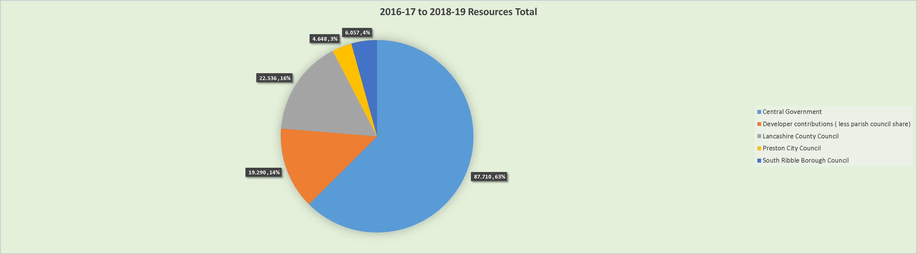

**Figure 2 – 2016-19 Expenditure Total**

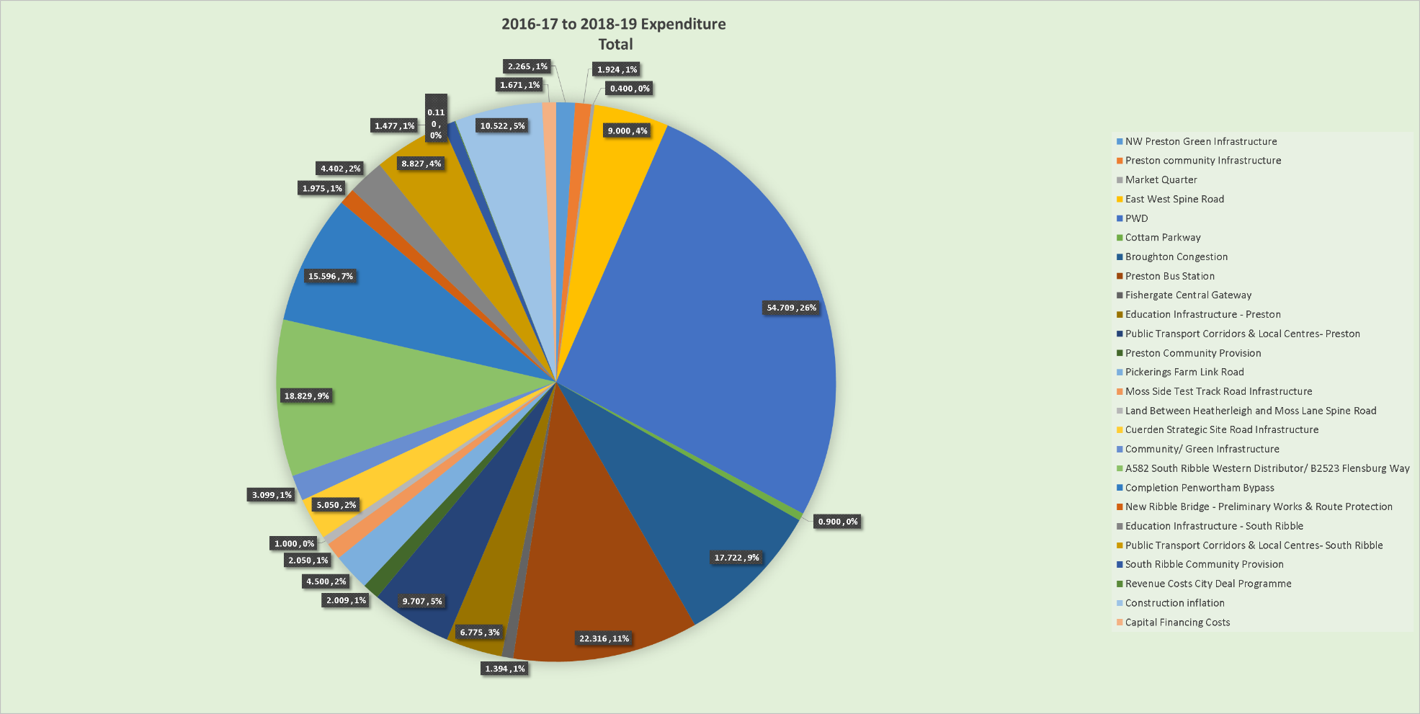

Housing Sites

The City Deal supports the delivery of 17,400 new homes across a range of strategic and smaller sites. Detailed delivery milestones for each of the sites are currently being developed and will be included in the refreshed version of this Plan in Summer 2017. The table below provides information on each of the sites identified in the City Deal agreement and provides a three year development projection for 2016-19.

**North West Preston**

|  |  |  |  |  |  |
| --- | --- | --- | --- | --- | --- |
| Site | No of units | No of units completed as at March 2016 | **Yr 3 16/17** | **Yr4 17/18** | **Yr5 18/19** |
| Cottam Hall | 326 | 0 | 0 | 13 | 40 |
| Cottam Hall - Site K | 104 | 38 | 30 | 36 | 0 |
| Cottam Hall - Phase 2 | 283 | 0 | 20 | 40 | 40 |
| Cottam Brickworks | 45 | 0 | 0 | 0 | 15 |
| North West Preston | 2,863 | 0 | 0 | 0 | 100 |
| North of Eastway | 300 | 0 | 0 | 30 | 30 |
| Eastway | 140 | 0 | 0 | 10 | 28 |
| Hoyles Lane | 350 | 21 | 0 | 23 | 30 |
| Maxy House Farm | 288 | 8 | 45 | 60 | 60 |
| Haydock Grange | 420 | 25 | 45 | 30 | 30 |
| Lightfoot Lane | 330 | 11 | 0 | 30 | 30 |
| Lightfoot Green Lane | 125 | 0 | 8 | 30 | 30 |
| Rear of RC Primary School | 22 | 0 | 13 | 9 | 0 |
| Sandyforth Lane | 182 | 0 | 0 | 20 | 30 |
| Tulketh Mill, Balcarres Road | 0 | 0 | 0 | 0 | 0 |
| Land North of Tom Benson Way | 30 | 0 | 0 | 0 | 30 |
| Land North of D'urton Lane | 112 | 0 | 0 | 30 | 40 |
| Land rr 122-152 Hoyles Lane | 48 | 0 | 0 | 0 | 24 |

**North East Preston**

|  |  |  |  |  |  |
| --- | --- | --- | --- | --- | --- |
| Site | No of units | No of units completed as at March 2016 | **Yr 3 16/17** | **Yr4 17/18** | **Yr5 18/19** |
| Whittingham Hospital | 650 | 5 | 30 | 30 | 60 |
| Land South of Whittingham Road (Moss Farm) | 78 | 22 | 40 | 16 | 0 |
| Whittingam Road (Ridings Depot) | 220 | 0 | 0 | 0 | 30 |
| Inglewhite Road | 190 | 0 | 0 | 30 | 30 |
| Fire & Rescue HQ, Garstang Road | 40 | 0 | 0 | 0 | 0 |
| Eastway Nurseries, Eastway | 13 | 0 | 0 | 13 | 0 |
| Sharoe Green Hospital | 55 | 0 | 0 | 0 | 25 |
| 2 Black Bull Lane | 0 | 0 | 0 | 0 | 0 |
| 167 Yewtree Avenue and 88 Fir Trees Avenue | 7 | 0 | 7 | 0 | 0 |
| Land off Forest Grove, Barton | 63 | 40 | 23 | 0 | 0 |
| Land off Ribblesdale Drive, Grimsargh | 70 | 0 | 10 | 30 | 30 |

**Preston City Centre**

|  |  |  |  |  |  |
| --- | --- | --- | --- | --- | --- |
| Site | No of units | No of units completed as at March 2016 | **Yr 3 16/17** | **Yr4 17/18** | **Yr5 18/19** |
| Parker Street | 50 | 0 | 0 | 0 | 0 |
| Goldenhill School, Cromwell Road | 20 | 0 | 0 | 20 | 0 |
| Tulketh Sports College, Tag Lane | 44 | 0 | 0 | 0 | 15 |
| Brethrens Meeting Rm, Egerton Road | 12 | 0 | 0 | 0 | 0 |
| Argyll Road Depot | 300 | 0 | 0 | 0 | 0 |
| Tetrad, New Hall Lane | 189 | 51 | 26 | 50 | 62 |
| Skeffington Road/Castleton Road | 38 | 0 | 0 | 0 | 0 |
| Deepdale Mill | 28 | 0 | 0 | 0 | 0 |
| Shelley Road/Wetherall Street | 27 | 0 | 0 | 0 | 0 |
| Stagecoach Bus Depot, Selbourne Street | 32 | 0 | 0 | 0 | 0 |
| Jubilee Trading Estate, Fylde Road | 64 | 30 | 34 | 0 | 0 |
| Spar Dist' Depot, Blackpool Road | 23 | 0 | 23 | 0 | 0 |
| Site Formerly Truro Place | 14 | 0 | 0 | 7 | 7 |
| 6 - 16 Marsh Lane | 20 | 0 | 20 | 0 | 0 |
| Ashton Basin Tulketh Brow | 12 | 0 | 0 | 0 | 12 |

**Non – Specific (Preston)**

|  |  |  |  |  |  |
| --- | --- | --- | --- | --- | --- |
| Site | No of units | No of units completed as at March 2016 | **Yr 3 16/17** | **Yr4 17/18** | **Yr5 18/19** |
| City Centre Allocations Allowance | 0 | 0 | 0 | 0 | 0 |
| City Centre Extant Planning Permissions | 0 | 0 | 0 | 0 | 0 |
| Re-use of Empty Homes | 975 | 98 | 0 | 0 | 0 |
| Extant Planning Permission | 0 | 0 | 0 | 0 | 0 |
| Additional Preston | 785 | 100 | 200 | 200 | 200 |

**Penwortham & Lostock Hall**

|  |  |  |  |  |  |
| --- | --- | --- | --- | --- | --- |
| Site | No of units | No of units completed as at March 2016 | **Yr 3 16/17** | **Yr4 17/18** | **Yr5 18/19** |
| Pickerings Farm | 1350 | 0 | 0 | 0 | 20 |
| Vernon Carus | 385 | 0 | 0 | 0 | 43 |
| South of Longton Hall, Chapel Lane | 80 | 0 | 0 | 0 | 20 |
| Land off the Cawsey | 75 | 71 | 4 | 0 | 0 |
| Land off Liverpool Road, Hutton | 46 | 0 | 0 | 0 | 20 |
| Wateringpool Lane | 80 | 11 | 35 | 34 | 0 |
| Land off School Lane, Longton | 69 | 4 | 0 | 0 | 16 |
| Lostock Hall Gasworks | 281 | 0 | 0 | 0 | 60 |
| Land at Longton Hall, Chapel Lane | 48 | 0 | 0 | 0 | 20 |
| Lostock Hall Primary, Avondale Drive | 20 | 0 | 0 | 0 | 0 |
| Gas Holders, Lostock Hall | 25 | 0 | 0 | 0 | 0 |
| Land off Claytongate Drive | 60 | 0 | 0 | 0 | 30 |

**Leyland & Cuerden**

|  |  |  |  |  |  |
| --- | --- | --- | --- | --- | --- |
| Site | No of units | No of units completed as at March 2016 | **Yr 3 16/17** | **Yr4 17/18** | **Yr5 18/19** |
| Moss Side Test Track | 750 | 0 | 0 | 0 | 0 |
| Moss Lane - North of Northern Section - Phase 1 | 200 | 0 | 0 | 0 | 0 |
| Moss Lane - North of Northern Section - Phase 2 | 200 | 0 | 0 | 0 | 0 |
| Moss Lane - South of Northern Section | 122 | 0 | 0 | 0 | 0 |
| Moss Lane - South of Southern Section | 175 | 0 | 16 | 32 | 32 |
| Moss Lane - North of Southern Section | 175 | 0 | 0 | 0 | 10 |
| Altcar Lane | 160 | 0 | 0 | 0 | 0 |
| Altcar Lane - Phase 1 | 180 | 0 | 0 | 0 | 50 |
| Altcar Lane - Phase 2 | 260 | 0 | 0 | 0 | 50 |
| Rear of Dunkirk Mill | 47 | 0 | 0 | 0 | 0 |
| Wheelton Lane | 468 | 102 | 50 | 55 | 55 |
| Grasmere Avenue | 160 | 0 | 0 | 0 | 20 |
| Roadferry Depot | 80 | 0 | 0 | 0 | 30 |
| Dunkirk Mill | 35 | 0 | 0 | 0 | 0 |
| Land South of Centurion Way (Northern) | 1 | 0 | 1 | 0 | 0 |
| Land South of Centurion Way (Southern) | 0 | 0 | 0 | 0 | 0 |

**Bamber Bridge**

|  |  |  |  |  |  |
| --- | --- | --- | --- | --- | --- |
| Site | No of units | No of units completed as at March 2016 | **Yr 3 16/17** | **Yr4 17/18** | **Yr5 18/19** |
| Land off Brindle Road - Phase 1 | 110 | 0 | 0 | 110 | 0 |
| Land off Brindle Road - Phase 2 | 140 | 0 | 0 | 140 | 0 |
| Coupe Foundry | 80 | 0 | 0 | 0 | 0 |
| Land off Brownedge Road | 60 | 0 | 0 | 0 | 0 |
| Arla Dairy, School Lane | 209 | 155 | 54 | 0 | 0 |
| Wesley Street Mill | 190 | 0 | 0 | 0 | 30 |

**Non – Specific (South Ribble)**

|  |  |  |  |  |  |
| --- | --- | --- | --- | --- | --- |
| Site | No of units | No of units completed as at March 2016 | **Yr 3 16/17** | **Yr4 17/18** | **Yr5 18/19** |
| Small sites with planning permission | 326 | 0 | 52 | 69 | 51 |
| Small sites identified in the SHLAA | 121 | 0 | 12 | 12 | 12 |
| Large sites under construction | 84 | 63 | 10 | 1 | 10 |
| Additional South Ribble | 772 | 0 | 0 | 0 | 0 |

**Completed Housing Sites**

|  |  |  |
| --- | --- | --- |
| Zone | Site | No of units completed |
| North West Preston | Lime Chase | 70 |
| North West Preston | Howarth Road, Tulketh | 15 |
| North East Preston | Brookfield Arms, Croasdale Avenue | 15 |
| North East Preston | NW Water Depot, Longridge Road | 34 |
| North East Preston | Booker Cash & Carry, Holme Slack Lane | 6 |
| Preston City Centre | 69 Bow Lane | 5 |
| Preston City Centre | Derby Inn, 212 Ribbleton Lane | 3 |
| Preston City Centre | Meadow House, Meadow Street | 14 |
| Preston City Centre | Land off Elizabeth Street | 5 |
| Preston City Centre | Stephenson's Arms, 21 - 23 East Street | 3 |
| Preston City Centre | DJ Ryan Depot, Inglewhite Road | 10 |
| Preston City Centre | Change of use (City Centre office to residential) | 215 |
| Penwortham & Lostock Hall | Former Prestolite Premises | 79 |
| Penwortham & Lostock Hall | Rear of Chapel Meadow, Longton | 14 |
| Penwortham & Lostock Hall | Liverpool Road/Jubilee Road | 72 |
| Penwortham & Lostock Hall | Land off Long Moss Lane | 29 |
| Leyland & Cuerden | Fishwick's Depot | 33 |
| Leyland & Cuerden | Group One | 220 |
| Leyland & Cuerden | LCC Offices, Brindle Road | 34 |
| Leyland & Cuerden | Former Prestolite Premises, Cleveland Road | 40 |
| Bamber Bridge | Brindle Road (Hospital Inn) | 32 |
| **Total** | | **948** |

Infrastructure Delivery 2016-19

The range of infrastructure schemes being delivered as part of the City Deal have been categorised and colour coded in the activity tables, as follows:-

Baseline at 2015/16 2015/16 actual and Projection at 2016/17

Highways and Transport Hubs

Public Transport Priority Corridors

Community Infrastructure Improvements

The activity tables which follow have been grouped by City Deal zone (set out at the end of this section) and provide high level information for each scheme and bring together the delivery forecasts with the related income/expenditure associated with that scheme.

Each infrastructure type has a standard set of milestones (with the exception of the community infrastructure revenue projects which have individually tailored milestones). The standardised milestones will make the progress monitoring process more streamlined. The milestones relevant to each scheme are set out in the activity table for ease of reference. A complete overview of all of the standardised milestones is set out below.

**Standard** **Delivery Milestones**

Community Infrastructure

1. Design developed and completed
2. Design approved
3. Planning application submitted
4. Planning application determined
5. Funding/match funding approved
6. Member decision
7. Contract documents complete
8. Contract awarded
9. Start on site
10. Site complete

Highway and Transport Hubs

1. Concept design complete
2. Consultation
3. Concept design approved
4. Outline business case submitted
5. Outline business case approved
6. Planning application submitted
7. Planning application determined
8. Commencement of land and property negotiation
9. CPO/SRO confirmed
10. Detailed design and contract documents complete
11. Full business case approved
12. Construction contract awarded
13. Start on site
14. Site complete

All of the City Deal infrastructure schemes and development sites have been grouped into one of the six area zones, which are:-

Zone 1 – North West Preston

Zone 2 – North East Preston

Zone 3 – Preston City Centre

Zone 4 – Penwortham and Lostock Hall

Zone 5 – Leyland and Cuerden

Zone 6 – Bamber Bridge

**Zone 1 – North West Preston**































**Zone 2 – North East Preston**





**Zone 3 – Preston City Centre**



















**Zone 4 – Penwortham & Lostock Hall**



















**Zone 5 – Leyland & Cuerden**









**Zone 6 – Bamber Bridge**



**Non Specific**







**Completed Schemes**



**RISK**

The table below provides a summary of the key programme risks that have been identified and their mitigation. As the City Deal continues to be implemented, the continuing changing environment will require additional risks to be identified and managed.

Ongoing risk management is undertaken at programme, project and operational levels to ensure risks are clearly identified and support the decision making process.

| **RISK TYPE** | | **MITIGATION MEASURE** |
| --- | --- | --- |
| **RESOURCE** | | |
| **1.** | **Quantity of Resource** | **Mitigation** |
| (i)The risk that the level of resources available from the different funding sources may be less than set out in the CD proposal.  (ii) The risk that there is a lack of skill and/or capacity to deliver the project, internally amongst the four partners. | | (ia) This risk has been mitigated by using prudent estimates of resources available, such as New Homes Bonus, CIL and Business Rates Retention. The financial values of HCA land receipts are based on the HCA's own assessments. Private sector contributions will be collected through robust and legally binding arrangements. Government policy changes to funding streams remains a risk and work is underway to analyse and mitigate.  (ib) A "*stress test"* of the funding model and the assumptions within it, is being undertaken, in order to reduce the risk of over committing the fund and under delivering the programme*.*  (ii) Expert resources are prioritised to the project by each partner. |
| **COST** | | |
| **2.** | **Cost Estimation** | **Mitigation** |
| The risk that the cost estimates set out in the City Deal (CD) may be outside accepted tolerances. | | 1. This risk was mitigated by basing initial CD costs on “live” tender costs and incorporating an optimism bias factor of 40%, in line with DfT guidelines. This therefore significantly reduces the risk of the cost outturn being under-estimated. This risk continues to be considered as further detailed design work is undertaken. 2. A "stress test" of the funding model and the assumptions within it, is being undertaken, in order to reduce the risk of over committing the fund and under delivering the programme. |
| **3.** | **Cost Overrun** | **Mitigation** |
| (i) The risk that, for infrastructure schemes and public transport corridor schemes, once land acquisition commences/compulsory purchase is concluded, unanticipated factors affecting land and compensation costs lead to an increase against estimates negatively impacting upon the infrastructure delivery fund  (ii) The risk that once construction commences unanticipated abnormal factors and/or changes to design could lead to an increase against tendered prices. | | (i) Partners will seek to be indemnified through relevant legal agreements against compensation claims.  (ii) This risk will be managed through LCC’s robust capital cost control processes to ensure costs are maintained within approved budgets and tendered prices. Any under-utilised resources will not be released until all identified cost pressures have been addressed. Ultimately, if it is not possible to mitigate adverse cost pressures, LCC, as the delivery agent for the infrastructure schemes, will manage any cost pressures within its overall capital programme. |
| **TIMING** | | |
| **4.** | **Phasing Shifts** | **Mitigation** |
| (i) The risk that the developments may not come forward in line with the timescales set out in the CD proposal.  (ii) The risk that licences and consents from third parties aren't sec  ured. | | 1. This risk has been mitigated through phasing of income in line with the statutory position of timescales when income streams, particularly New Homes Bonus and Business Rates, are payable. Legal agreements to capture private sector contributions will aim to ensure that private sector contributions are phased in line with the CD Infrastructure Delivery Programme. In addition and in recognition of the fact that the cash flow profile for the Infrastructure Delivery Programmeis not even, Lancashire County Council will financially stand behind the CD to allow both the base case cash-flow and some degree of slippage to be effectively managed. In addition, the close monitoring of both incoming resources and expenditure will allow sufficient advance warning of issues for further mitigating action, such as adjustments to programme phasing, to be undertaken without destabilising the overall programme. 2. Assumptions made in the original delivery model are also continuously tested to give an updated forecast of likely development timescales 3. Work is underway to look at opportunities for streamlining the planning process ensure CD applications can be dealt with efficiently to make sure that delivery and output timescales are met. 4. Effective forward planning and early engagement with statutory bodies. |
| **PLANNING** | | |
| **5.** | **Delay in Road Planning** | **Mitigation** |
| (i) The risk that road schemes may be subject to both local and national planning processes thereby increasing delivery timescales.  (ii) The risk that road schemes may be delayed through local planning processes.  (iii) The risk that road schemes may be delayed due to inability to assemble land.  (iv) The risk that the scheme may be delayed by Highway Act procedures. | | (i) This risk is likely to be wholly mitigated through proposed amendments to the Planning Act which will remove the need for local major schemes, which connect into the Strategic Road Network, to use the Development Control Order Process.  (ii) In addition, the road schemes are set out in the Central Lancashire Highways and Transport Masterplan, adopted in March 2013, and therefore have already been subject to extensive consultation.  (iii) & (iv) This will be mitigated through early commencement of the order processes and land acquisitions. |
| **6.** | **Planning Approval** | **Mitigation** |
| (i) The risk that housing/employment sites set out in the CD proposals may not receive planning consent as they are brought forward by the private sector.  (ii) The risk of planning appeals.  (iii) The risk that sites don't get allocated because Masterplans are not in place. | | (i), (ii) & (iii) This risk has been mitigated, as all housing and employment sites set out in the CD area are set within the Central Lancashire Core Strategy, adopted in summer 2012, and therefore have already been subject to extensive consultation. The CD local authorities welcome the scope and scale of development set out in the Core Strategy. Site Allocations, Masterplans and other development documents are being resourced and progressed to ensure that proposals are supported by an up-to-date development plan. Overall, this risk continues to be monitored closely to make sure that delivery and output timescales are met. |
| **COMMERCIAL** | | |
| **7.** | **Commercial Delivery** | **Mitigation** |
| (i) The risk that the private sector may not come forward with investment proposals for housing and employment sites.  (ii) The risk that landowners may not sell due to market viability issues.  (iii) The risk that sites outside the agreed list of City Deal development sites come forward and undermine the City Deal Programme. | | (i), (ii) & (iii) This risk has been mitigated, in part, through the proven private sector confidence and investment appetite in the CD area. House-builders and commercial developers are willing to invest in schemes and associated infrastructure and to secure end users, subject to a clear strategy to provide the critical infrastructure set out in the CD.  Ultimately, commercial delivery will be influenced by national and international economic conditions and overall, this risk continues to be monitored closely to make sure that delivery and output timescales are met. |
| **MARKETING AND COMMUNICATION** | | |
| **8.** | **Consultation and marketing risk** | **Mitigation** |
| (i) The risk that the project is not communicated adequately to all stakeholders.  (ii) The risk that the potential of City Deal is not marketed sufficiently to attract people to live and work in the area.  (iii) The reputational risk to all partner authorities if the Deal fails to deliver the intentions and aspirations set out in the Agreement | | (i) & (ii) Early communication and establishment of working forums with key stakeholder groups, supported by a robust marketing and communications plan put in place for each project.   1. Robust partnership working in place supported by strong governance arrangements and an effective marketing and communications plan. 2. A strong focus is on promoting central Lancashire regionally and nationally, to attract inward investment and appeal to a business audience. |
| **POLICY** | | |
| **9.** | **New Homes Bonus/CIL/NNDR Policy Change** | **Mitigation** |
| The risk that Government may change its policy regarding the New Homes Bonus/CIL/NNDR thereby reducing the resources available to deliver the CD Delivery Infrastructure Programme. | | A piece of work is being done to identify the impact of proposed changes in national policy on the City Deal. Any risks identified will be managed through negotiation between Government, the LEP and CD local authorities. |
| ***POLITICAL*** | | |
| **10.** | **Political Administration Change** | **Mitigation** |
| (i) The risk that local political administration changes may impact upon the CD proposals.  (ii) The risk of being unable to secure partner agreement and co-operation throughout the life of the CD programme. | | (i) & (ii) This risk has been mitigated by the respective Cabinets for each of the 3 CD local authorities endorsing the CD. City Deal governance arrangements provide the mechanism for managing this. |

**Index of Infrastructure Schemes and Development Sites**

**Zone 1 – North West Preston**

|  |  |  |
| --- | --- | --- |
| Scheme Type | Scheme | Pg Number |
| Highways & Transport Hubs | Broughton Bypass | 24 |
| Highways & Transport Hubs | Preston Western Distributor | 25 |
| Highways & Transport Hubs | East West Link Road | 26 |
| Highways & Transport Hubs | Cottam Parkway | 27 |
| Priority Corridor/Local Centre | Broughton/Fulwood (North of M55) | 28 |
| Priority Corridor/Local Centre | Broughton/Fulwood (South of M55) | 29 |
| Priority Corridor/Local Centre | North West Preston/Cottam/Ingol/City Centre | 30 |
| Priority Corridor/Local Centre | Warton to Preston Western Distributor | 31 |
| Community Infrastructure | Guild Wheel Phase 1 – Bluebell Way | 32 |
| Community Infrastructure | Guild Wheel Phase 2 – Watery Lane | 33 |
| Community Infrastructure | Guild Wheel Phase 3 – Blackpool Road | 34 |
| Community Infrastructure | Lancaster Canal Towpath | 35 |
| Community Infrastructure | Tom Benson Way | 36 |
| Community Infrastructure | Guild Wheel Improvements | 37 |
| Community Infrastructure | Upgrade of Existing Gates | 38 |

**Zone 2 – North East Preston**

|  |  |  |
| --- | --- | --- |
| Scheme Type | Scheme | Pg Number |
| Priority Corridor/Local Centre | Longridge/Grimsargh/Ribbleton/City Centre | 39 |
| Community Infrastructure | Grimsargh Green | 40 |

**Zone 3 – Preston City Centre**

|  |  |  |
| --- | --- | --- |
| Scheme Type | Scheme | Pg Number |
| Highways & Transport Hubs | Preston Bus Station | 41 |
| Highways & Transport Hubs | Fishergate Central Gateway - Phase 3 | 42 |
| Highways & Transport Hubs | Fishergate/Winckley Sq - P1 THI | 43 |
| Priority Corridor/Local Centre | PWD to Samlesbury - Corridor & Local Centre | 44 |
| Community Infrastructure | Preston Bus Station - Youth Zone | 45 |
| Community Infrastructure | Fishergate/Winckley Sq - P2 Winckley Sq Gardens | 46 |
| Community Infrastructure | East Cliff Cycle Hub | 47 |
| Community Infrastructure | East Cliff Bridge & Cycle Link | 48 |
| Community Infrastructure | Extended City Cultural Development Programme | 49 |

**Zone 4 – Penwortham & Lostock Hall**

|  |  |  |
| --- | --- | --- |
| Scheme Type | Scheme | Pg Number |
| Highways & Transport Hubs | Penwortham Bypass | 50 |
| Highways & Transport Hubs | A582 Pope Lane Roundabout | 51 |
| Highways & Transport Hubs | A582 Dualling | 52 |
| Highways & Transport Hubs | Pickerings Farm Link Road | 53 |
| Highways & Transport Hubs | New Ribble Crossing | 54 |
| Priority Corridor/Local Centre | Hutton to Higher Penwortham | 55 |
| Priority Corridor/Local Centre | North of Lostock Lane | 56 |
| Community Infrastructure | Landmark Features – Iron Horse | 57 |
| Community Infrastructure | Landmark Features – Leyland Tractor | 58 |

**Zone 5 – Leyland & Cuerden**

|  |  |  |
| --- | --- | --- |
| Scheme Type | Scheme | Pg Number |
| Highways & Transport Hubs | Heatherleigh and Moss Lane (Croston Road) Spine Road | 59 |
| Highways & Transport Hubs | Moss Side Test Track Road Infrastructure | 60 |
| Highways & Transport Hubs | Cuerden Strategic Site Road Infrastructure | 61 |
| Priority Corridor/Local Centre | South of Lostock Lane | 62 |

**Zone 6 – Bamber Bridge**

|  |  |  |
| --- | --- | --- |
| Scheme Type | Scheme | Pg Number |
| Priority Corridor/Local Centre | Bamber Bridge/City Centre | 63 |

**Non-Specific**

|  |  |  |
| --- | --- | --- |
| Scheme Type | Scheme | Pg Number |
| Community Infrastructure | Central Park Development Plan | 64 |
| Community Infrastructure | Leisure Development Plan | 65 |
| Community Infrastructure | Cycling Strategy | 66 |